Instituto Tecnológico y de Estudios Superiores de Monterrey

“Campus Querétaro"



**Filtering in video displaying**

Programming languages final project

**Author:**

A01704446 Viviana Elizabeth Dueñas Chávez

**Professor:**

Benjamín Valdés Aguirre

May 27, 2021

**1 Context**

* 1. **Introduction**

Retinal diseases are the most common cause of childhood blindness worldwide. The retina is the tissue placed on the back of the eye, in charge of photoreception and light processing for visual recognition. The eye has photoreceptor cells capable of detecting qualities of color and light intensities. This is the information that the retina senses and transform to signals for vision purposes.

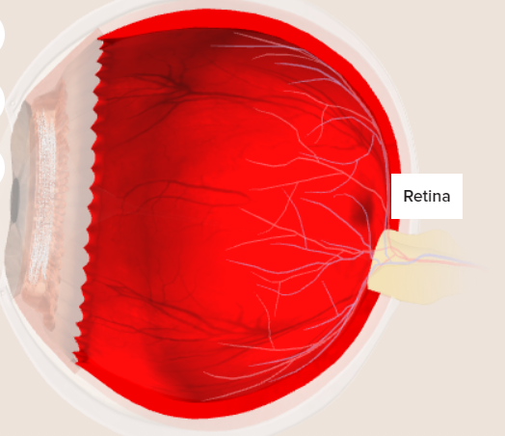

**Figure 1.-** Eye structure highlighting the retina layer. Retrieved from:

https://www.healthline.com/human-body-maps/retina#1

The causes of blindness changes per wealthiness on each country, but the common denominator in middle, like in Latin America, and most wealthy countries are diseases due to retina damages. The leading causes of blindness in those regions are retina diseases.

Nowadays, the bionic eye, an implant capable of restoring sight, is a fact in the ophthalmological field, letting patients completely blind, due to a damaged the retina, a common cause in old people, to perceive the surroundings in a grayscale of 576-pixel range. The most recent method places the vision-restoring sensor (camera) on top of the patient’s retina and power it with an external laser, as follows in Figure 1:

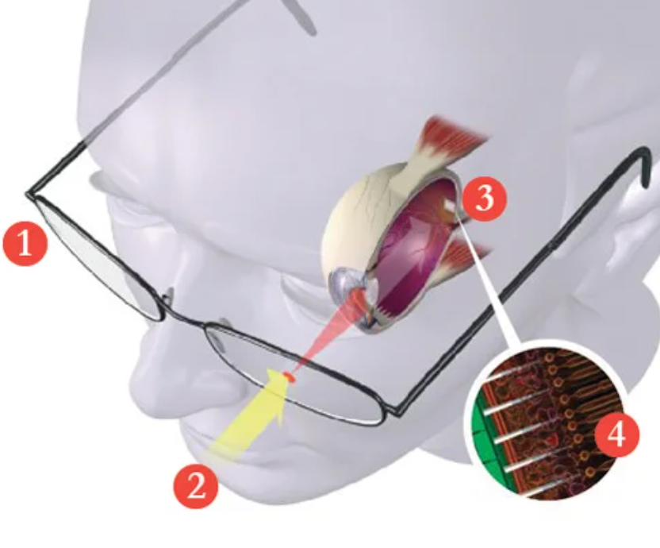

**Figure 2.-** Bionic implant and its external laser-powering demonstration. Retrieved from:

https://www.popsci.com/technology/article/2012-06/bio-retina-implant-could-give-sight-blind-laser-power/

Each of the shades of the grayscale range is being calculated from an image processor that receives the light information given by the photoreceptors on the chip, that replaces the missing photoreceptor cells sensing and processing operations, caused by a retina disease.

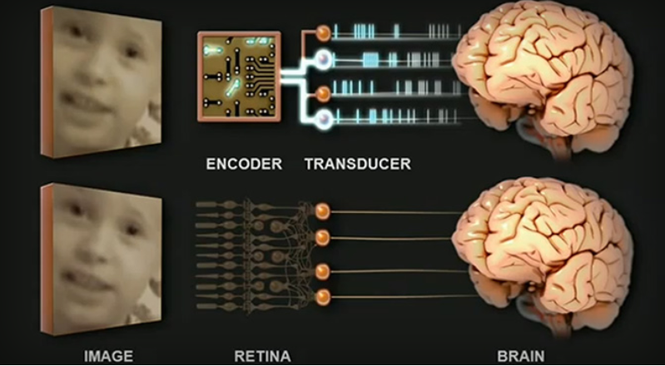

**Figure 3.-** Bionic implant sensors/transducer comparison with the retina. Retrieved from:

<https://www.extremetech.com/extreme/110031-a-bionic-prosthetic-eye-that-speaks-the-language-of-your-brain>

Due to this problem and new technology, capable of giving a grayscale vision to the blind, this project approaches the alternative of using filtering for improving the object recognition in the whole image perception. More specifically, the project navigates the possibility of applying edge detection to a video capture, which resembles the video-sensing chip (camera), installed as the bionic eye or the replacement of the damage retina, information.

* 1. **Image processing**

A digital image can be saw as spaces of memory in which certain information, about a shade or a color, depending on the format, is stored. On the other hand, a digital video will be a representation of a sequence of digital images in binary format. Which basically means, an amount of images in a given period. For this Project, an image will be seen as a 2-dimensional matrix, stored as long line, that contains the information discussed before plus its header that can tell us sizing and format information.

For image processing, there is a technique called “Kernel convolution” which let the applying of filters like blurring and edge detection on digital images. This kernel is matrix smaller than the original image. This structure is passed over the whole image, which is transformed based on the number within the kernel used. For example, if we use a 3x3 convolution kernel, filled with just the number 1, the result obtained would be the application of a blurring filter. The overall result of doing this is a weighted average, since each of the numbers in the kernel are being multiplied by each pixel of the original image, being summed, and divided by the total number of elements in the kernel.

After applying a convolutional kernel to a digital image, the output needs to be placed on a different image for avoiding messing with the original data. The resulting convoluted image is a bit smaller than the original, so the input image needs to have a little “padding” on the borders to maintain the sizing defined in the header.

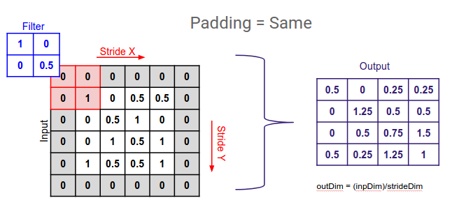

**Figure 4.-** Convolutional kernel (left), padding technique (middle) and the resulting convoluted image (right).

Retrieved from: https://deepai.org/machine-learning-glossary-and-terms/padding

The “padding” is for the edges of the image, that are usually lost after the convolution step, and can be done by just a zero filling (shown in Figure 4 and 5), a duplication of the borders pixels or by passing the kernel through it with zeros instead of the missing pixels due the border's nature, ignoring the data is undetermined and trying to get the calculations on the border pixel as well.

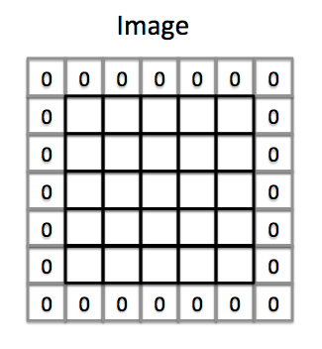

**Figure 5.**- Zero filling method for padding the image. Retrieved from:

https://medium.com/machine-learning-algorithms/what-is-padding-in-convolutional-neural-network-c120077469cc

* 1. **Edge detection**

In general, the edge detection is a tool that helps us identify the sharpe changes of intensities in an image:

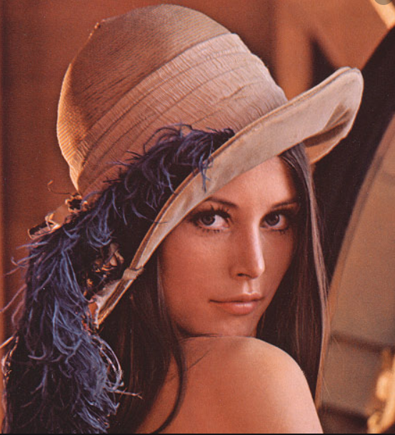 

Low intensity

High intensity

**Figure 6.**- Contrast of intensity levels.

Original Lena’s image (Left) retrieved from: Rick Swenson’s robotic vision material.

The Sobel filter is a way of getting the edges on an image. There can be horizontal and vertical edges:

a)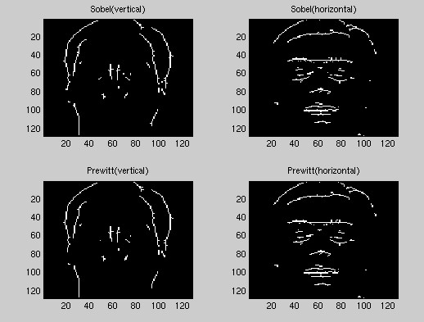 b)

**Figures 7.-** a) shows the vertical edges using one of the Sobel gradients, and the figure b) shows the horizontal ones.

For calculating the x-gradient, figure 8a, which calculates the derivative of the image to highlighting the vertical changes, we need to use a Sobel operator, that basically separates one region to the other vertically. For the y-gradient, figure 8b, which calculates the same derivative but for highlighting the horizontal edges, we need to use another symmetric Sobel operator, which, as shown before, separates the regions to check for a sharpe change of intensities horizontally:

1. Gx: 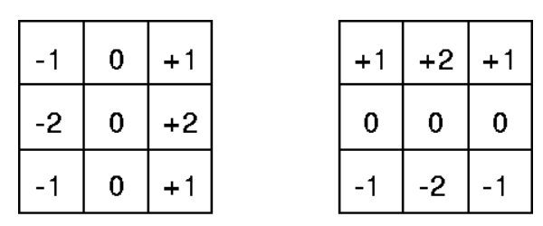 b) Gy: 

**Figures 8.-** a) shows the x gradient, and the figure b) shows the y gradient.

This “Sobel operators” are the convolutional kernels applied to each pixel of the image. One kernel for each of the two, as a 2d-dimensioned image, perpendicular orientation. When there is no change the opposite signs in the kernel make the resulting value 0. The gradients are calculated separately from the same input image, and then mixed for the final absolute gradient calculation per pixel, as shown on figures 8a and b, which is the resulting value of applying the Sobel’s filter. Therefore, the resulting sign of the x and y gradients does not affect the result at all.

a)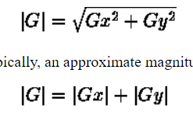 b)

**Figures 9.-** a) shows the absolute magnitude value for each orientation, and the figure b) shows the approximation of that magnitude. Retrieved from: https://homepages.inf.ed.ac.uk/rbf/HIPR2/sobel.htm

**Solution**

For this problem, my proposed solution was to implement a program capable of applying Sobel filter into real time video capturing. That means, a lot of calculations needed to be done at a time. For just one image, we need to apply 2 kernel convolutions, which means twice the calculations per pixel, and for video capturing, per image.

Due to the nature of image processing and the digital image itself, being taken as big matrix, the parallelizing method is the best approach. That is why I chose to implement this in CUDA, using the GPU cores to do all the calculations at once. The corresponding comparison of the time that takes doing the calculations in CPU vs GPU, will be displayed to check the advantage of parallelizing.

* 1. **Algorithm (Overall flow diagram)**

**The program is going to**

* 1. **Architecture solution (Tools, steps)**

**Results**

introduce Comparación de CPU vs GPU en materia de cálculos para procesamiento de la imagen.

Sequential in C vs CUDA

Varias pruebas realizadas. --- Mostrar la mejora en porcentaje de unas 4 veces.

Agregar tabla de tiempos y gráficas de rendimiento.

Agregar pruebas de Edge detenction con varios tipos de backgrounds, si existe error, mencionarlo en los comentarios a modo de observaciones.

**Conclusions**

oIn conclusion, we can see how useful can be to be able of calculating a lot of things at a time when doing applycations like the image processing filtering, which basically is based on doing the same amont of calcs for each pixel, and, in video cases, per image at a time. Blab la bla. Copiar un poco la estructura de otros proyectos.

Mejoras. Observaciones.

**Setup instructions**

Lit copier la estructura de otros proyectos en esto.

Steps de cómo instalar, setear la compu y el VS. Cómo compilarlo y correrlo.

**References**

1) R., “Image Processing: Edge Detection,” Rice Web Services, n.d. [Online]. Available: <https://www.owlnet.rice.edu/%7Eelec539/Projects97/morphjrks/moredge.html>. [Accessed: 29-May-2021].

2) C., “YouTube,” YouTube, 04-Nov-2015. [Online]. Available:

<https://www.youtube.com/watch?v=uihBwtPIBxM>. [Accessed: 29-May-2021].

Anthony, S. (2011, December 22). *A bionic prosthetic eye that speaks the language of your brain*. ExtremeTech. https://www.extremetech.com/extreme/110031-a-bionic-prosthetic-eye-that-speaks-the-language-of-your-brain

Cooper, A. (2021, April 26). *Bio-Retina Implant Could Give Laser-Powered Sight to the Blind*. Popular Science. <https://www.popsci.com/technology/article/2012-06/bio-retina-implant-could-give-sight-blind-laser-power/>

Anthony, S. (2012, July 17). *The laser-powered bionic eye that gives 576-pixel grayscale vision to the blind*. ExtremeTech. https://www.extremetech.com/extreme/132918-the-laser-powered-bionic-eye-that-gives-576-pixel-grayscale-vision-to-the-blind

Computerphile. (2015, February 15). *Digital Images - Computerphile* [Video]. YouTube. <https://www.youtube.com/watch?v=06OHflWNCOE&ab_channel=Computerphile>

The Healthline Editorial Team. (2018, January 22). *Retina*. Healthline. https://www.healthline.com/human-body-maps/retina#1

Healthline. (2003). *Retinal Diseases and VISION 2020*. PubMed Central (PMC). <https://www.ncbi.nlm.nih.gov/pmc/articles/PMC1705858/>

Torpy, J., Glass, T., & Glass, R. (2007). *Retinopathy*. JAMA Network. <https://jamanetwork.com/journals/jama/fullarticle/208559#:~:text=Retinopathy%20means%20disease%20of%20the,the%20small%20retinal%20blood%20vessels>.

Retinal Diseases and VISION 2020. (2003). *Community eye health*, *16*(46), 19–20. Retrieved by: <https://www.ncbi.nlm.nih.gov/pmc/articles/PMC1705858/>